Assignment # 4 Name: Tarun Banda

Program 1: Distance.java

**Screenshot (Sample Run) :**  GIVE IMAGE screen shot of the program running

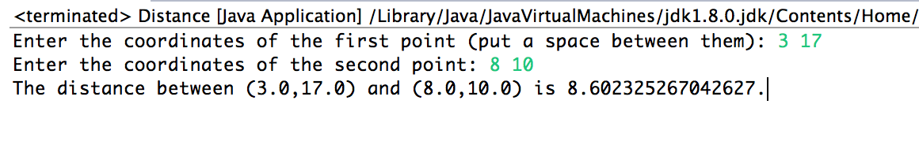

Program 2: StringManips.java

**Screenshot (Sample Run):** GIVE IMAGE screen shot of the program running

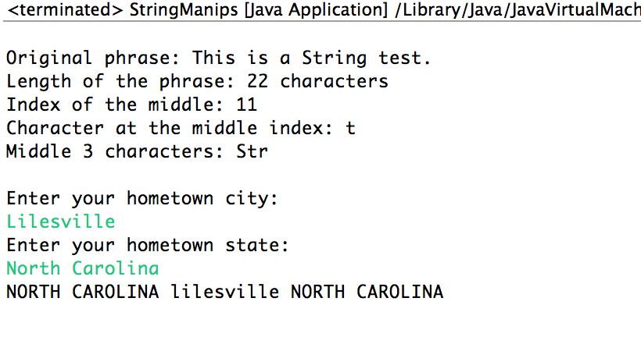

Program 3: Payroll.java

**Screenshot (Sample Run):** GIVE IMAGE screen shot of the program running 